Business Requirements:
- Controller for parking access which support multiple communication protocol

Parking Access Control Board Peripherals:
- Short-Range: Wiegand/RS485 (2 GPIO + GND)/RS232 (4 GPIO + GND).
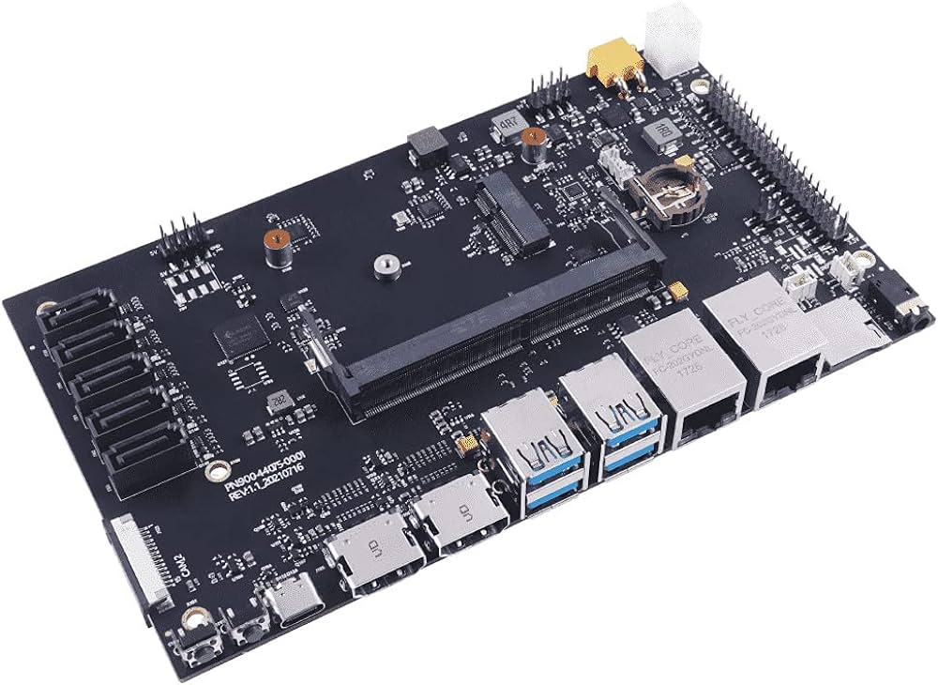
- QR Reader: USB.
- Mic/Speaker Microphone and Speaker.
- Intercom Network/Ethernet.
- ANPR Camera Ethernet.
- Ticket Printer USB.
- Activation LED 1 GPIO.
- Reserved GPIO (1-3)- Status – RGB LED.
- Inductive Loop GPIO (3 IN + GND).
- Barrier Control GPIO (5 Pin “Relay” + Vcc + GND).
- CCTV pin hole camera stripe block or USB.
- Display –> ??
CPU | Quad-core Arm Cortex A76 processor @ 2.4GHz
RAM | Min. 4GB LPDDR4-3200 SDRAM and extendable up to 32 or higher
ROM | Min. 32GB eMMC Flash memory
Storage | SD Card up to 512 GB.
GPU | NVIDIA (Optional)
USB | Min. 3 (Extra 1)
Wiegand | Min. 1 (Extra 1)
RS232 | Min. 1 (to be confirmed) – 4 GPIO
RS485 | Min. 1 (to be confirmed) – 3 GPIO
Relay | Min. 5 (Extra 3) – 5-8 GPIO
Ethernet | Yes
Wi-Fi | Optional
GSM/SIM Card | Mandatory
Bluetooth | Bluetooth 5.0, BLE (Optional)
GPIO | Min. 13-28 (Externally or embeded. Provide recommendations)
Temp. | -20C – 65C
Humidity | 0%-98% (noncondensing)
Dimensions | 15.00 x 15.00 cm (Recommendation for smaller)
HW Status LED | 1 x RGB for booting and HW status.
Provition LEDs | 6 x RGB for device activation (Optional)
Mic | Optional
Speaker | Optional
Intercom action Button | 1 GPIO (Optional)
Display | ??
HDMI | Optional
Action Buttons | 4 GPIO (Optional)
Receipt Printer | USB (Optional)
Sensors | Temp + Humidity

